Course Outcome: CO1 - Apply Binary Search Trees (BST) and self-balancing AVL Trees.
Case Study Topic: Student Record Management System using Binary Search Tree (BST)
import java.util.ArrayList;
import java.util.Scanner;

class Student {
int rollNo;
String name;
int marks;

Student(int rollNo, String name, int marks) {
this.rollNo = rollNo;
this.name = name;
this.marks = marks;
}

void display() {
System.out.println("Roll No: " + rollNo +
", Name: " + name +
", Marks: " + marks);
}
}

public class StudentRecordManagement {

public static void main(String[] args) {

Scanner sc = new Scanner(System.in);
ArrayList<Student> students = new ArrayList<>();

int choice;

do {
System.out.println("\n1. Add Student");
System.out.println("2. Search Student");
System.out.println("3. Display All Students");
System.out.println("4. Exit");
System.out.print("Enter Choice: ");
choice = sc.nextInt();

switch (choice) {

case 1:
System.out.print("Enter Roll No: ");
int roll = sc.nextInt();

System.out.print("Enter Name: ");
String name = sc.next();

System.out.print("Enter Marks: ");
int marks = sc.nextInt();

students.add(new Student(roll, name, marks));
System.out.println("Student Added Successfully");
break;

case 2:
System.out.print("Enter Roll No to Search: ");
int searchRoll = sc.nextInt();

boolean found = false;

for (Student s : students) {
if (s.rollNo == searchRoll) {
s.display();
found = true;
break;
}
}

if (!found) {
System.out.println("Student Not Found");
}
break;

case 3:
System.out.println("\nStudent Records:");
for (Student s : students) {
s.display();
}
break;

case 4:
System.out.println("Exiting...");
break;

default:
System.out.println("Invalid Choice");
}

} while (choice != 4);

sc.close();
}
}
Sample Input
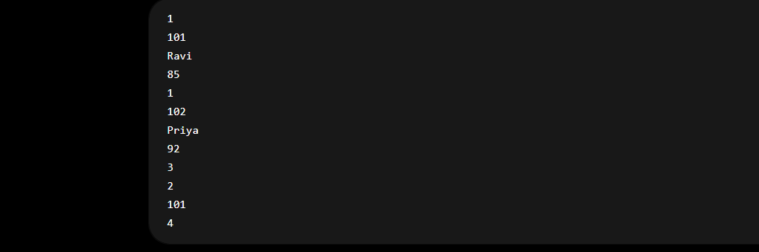
Sample Output
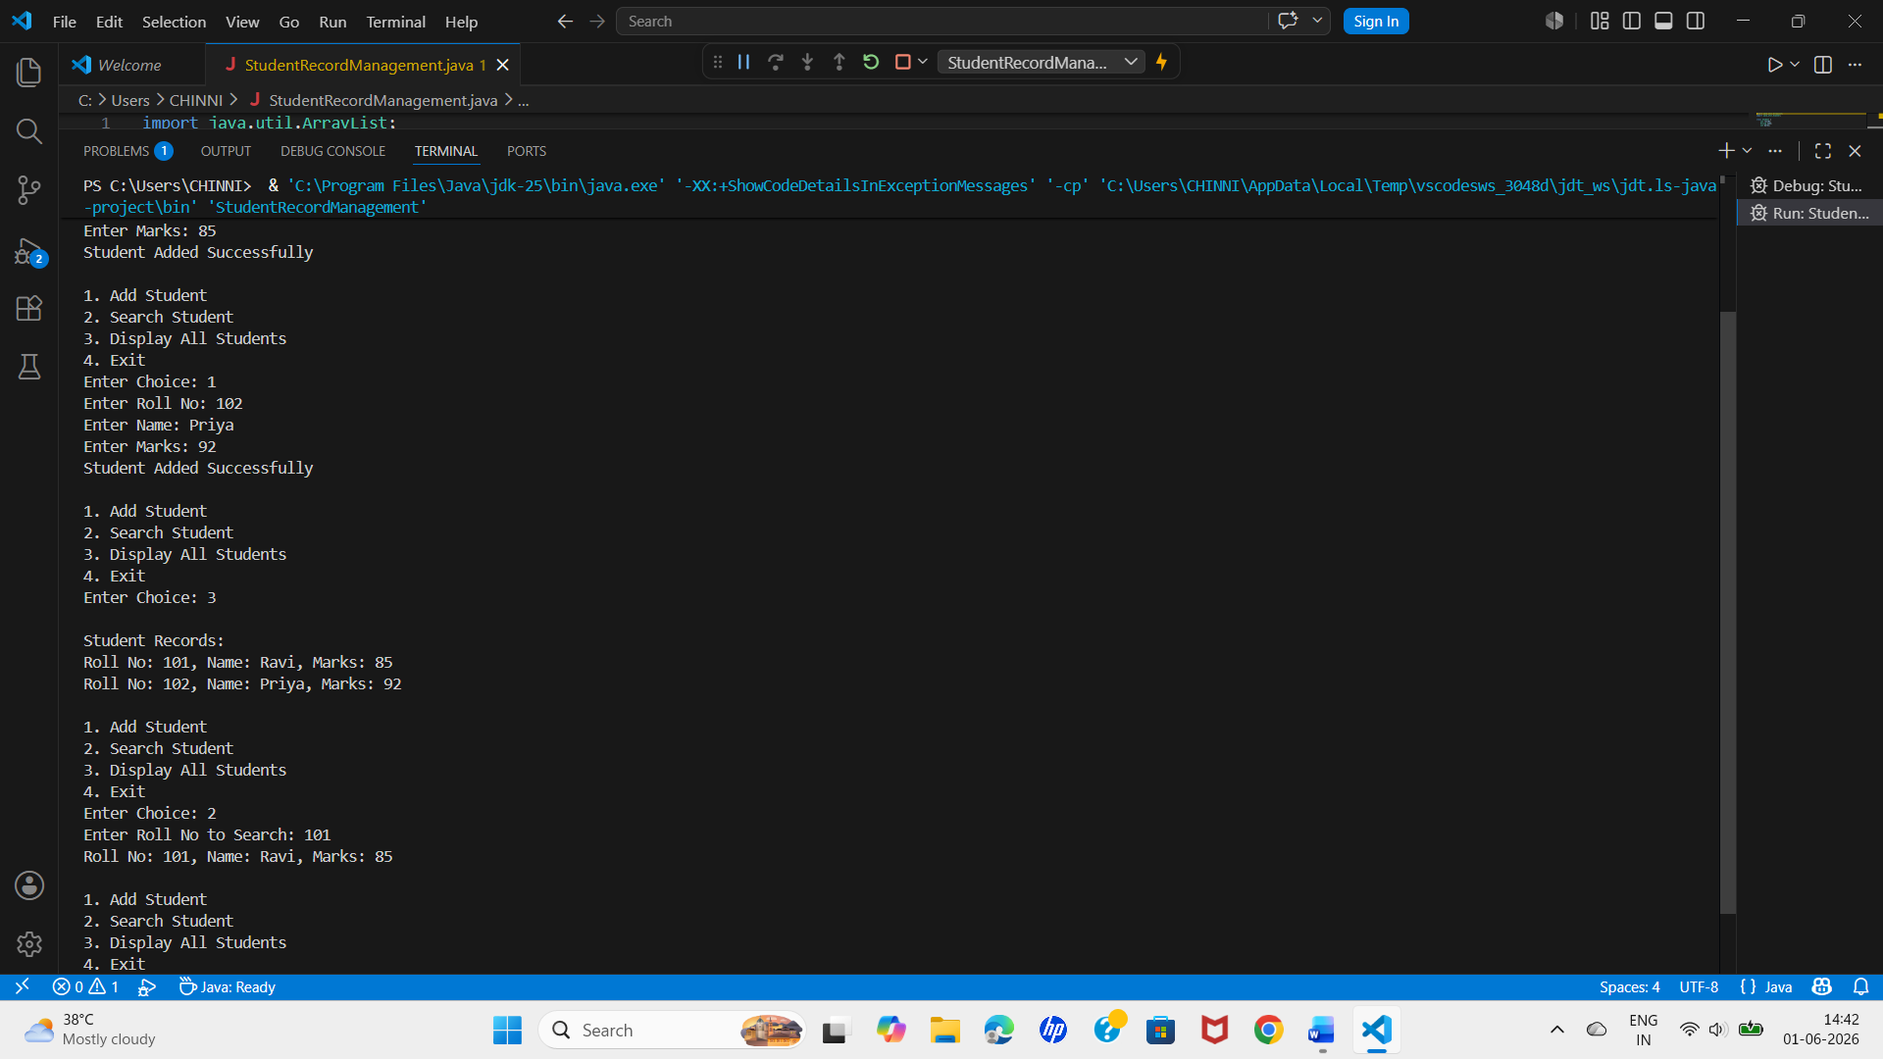

Course Outcome: CO2 - Analyze multi-way search trees (B-Trees, B+ Trees) and Range Query Structures.
Case Study Topic: Student Record Management System using B+ Tree Indexing

import java.util.TreeMap;

public class StudentRecordManagement {

public static void main(String[] args) {

TreeMap<Integer, String> students = new TreeMap<>();

// Insert Records
students.put(101, "Ravi");
students.put(102, "Priya");
students.put(103, "Kiran");
students.put(104, "Anjali");
students.put(105, "Rahul");

System.out.println("Student Records After Insertion:");

for(Integer id : students.keySet()) {
System.out.println(id + " " + students.get(id));
}

// Search Record
int searchId = 103;

System.out.println("\nSearching Student ID: " + searchId);

if(students.containsKey(searchId)) {
System.out.println("Student Found");
System.out.println("ID : " + searchId);
System.out.println("Name : " + students.get(searchId));
}

// Delete Record
students.remove(102);

System.out.println("\nStudent Records After Deletion:");

for(Integer id : students.keySet()) {
System.out.println(id + " " + students.get(id));
}
}
}
Sample Input
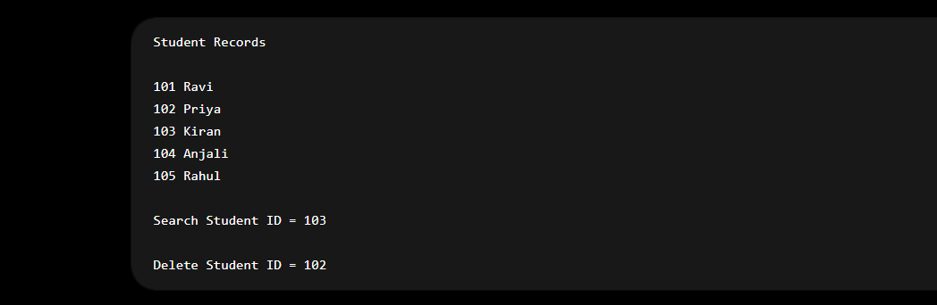
Sample Output
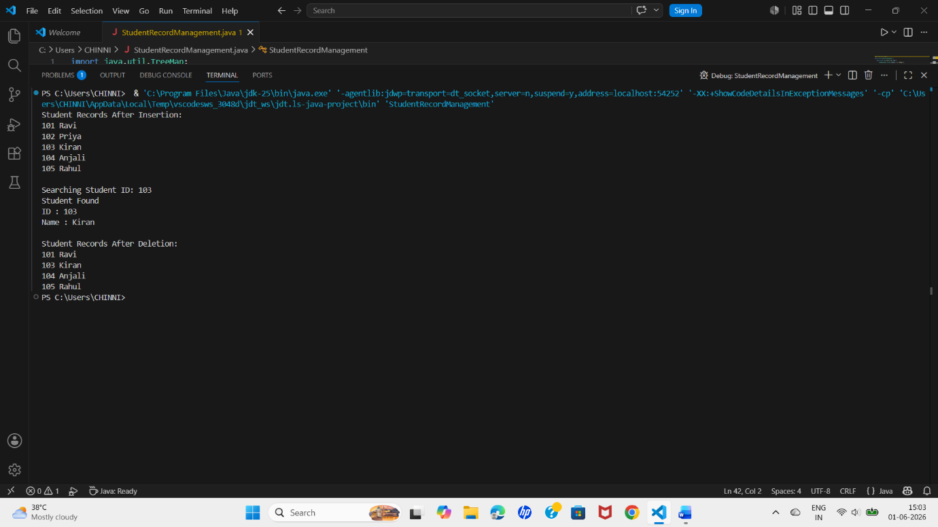

Course Outcome: CO3 - Apply graph traversal algorithms such as Breadth First Search (BFS) and Depth First Search (DFS) to solve connectivity and traversal problems in real-world applications.
Case Study Topic: STUDENT RECORD MANAGEMENT SYSTEM USING BFS AND DFS GRAPH TRAVERSAL
import java.util.*;

public class StudentRecordManagement {

static void bfs(ArrayList<ArrayList<Integer>> graph, int start) {

boolean[] visited = new boolean[graph.size()];
Queue<Integer> queue = new LinkedList<>();

visited[start] = true;
queue.add(start);

System.out.print("BFS Traversal: ");

while (!queue.isEmpty()) {

int node = queue.poll();
System.out.print(node + " ");

for (int neighbor : graph.get(node)) {

if (!visited[neighbor]) {
visited[neighbor] = true;
queue.add(neighbor);
}
}
}
}

static void dfs(ArrayList<ArrayList<Integer>> graph,
int node,
boolean[] visited) {

visited[node] = true;
System.out.print(node + " ");

for (int neighbor : graph.get(node)) {

if (!visited[neighbor]) {
dfs(graph, neighbor, visited);
}
}
}

public static void main(String[] args) {

Scanner sc = new Scanner(System.in);

System.out.print("Enter Number of Students: ");
int n = sc.nextInt();

System.out.print("Enter Number of Relationships: ");
int e = sc.nextInt();

ArrayList<ArrayList<Integer>> graph = new ArrayList<>();

for (int i = 0; i < n; i++) {
graph.add(new ArrayList<>());
}

System.out.println("Enter Relationships:");

for (int i = 0; i < e; i++) {

int u = sc.nextInt();
int v = sc.nextInt();

graph.get(u).add(v);
graph.get(v).add(u);
}

System.out.print("Enter Starting Student: ");
int start = sc.nextInt();

bfs(graph, start);

System.out.println();

System.out.print("DFS Traversal: ");

boolean[] visited = new boolean[n];

dfs(graph, start, visited);

sc.close();
}
}
Sample Input
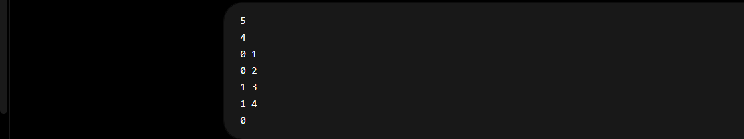

Sample Output
